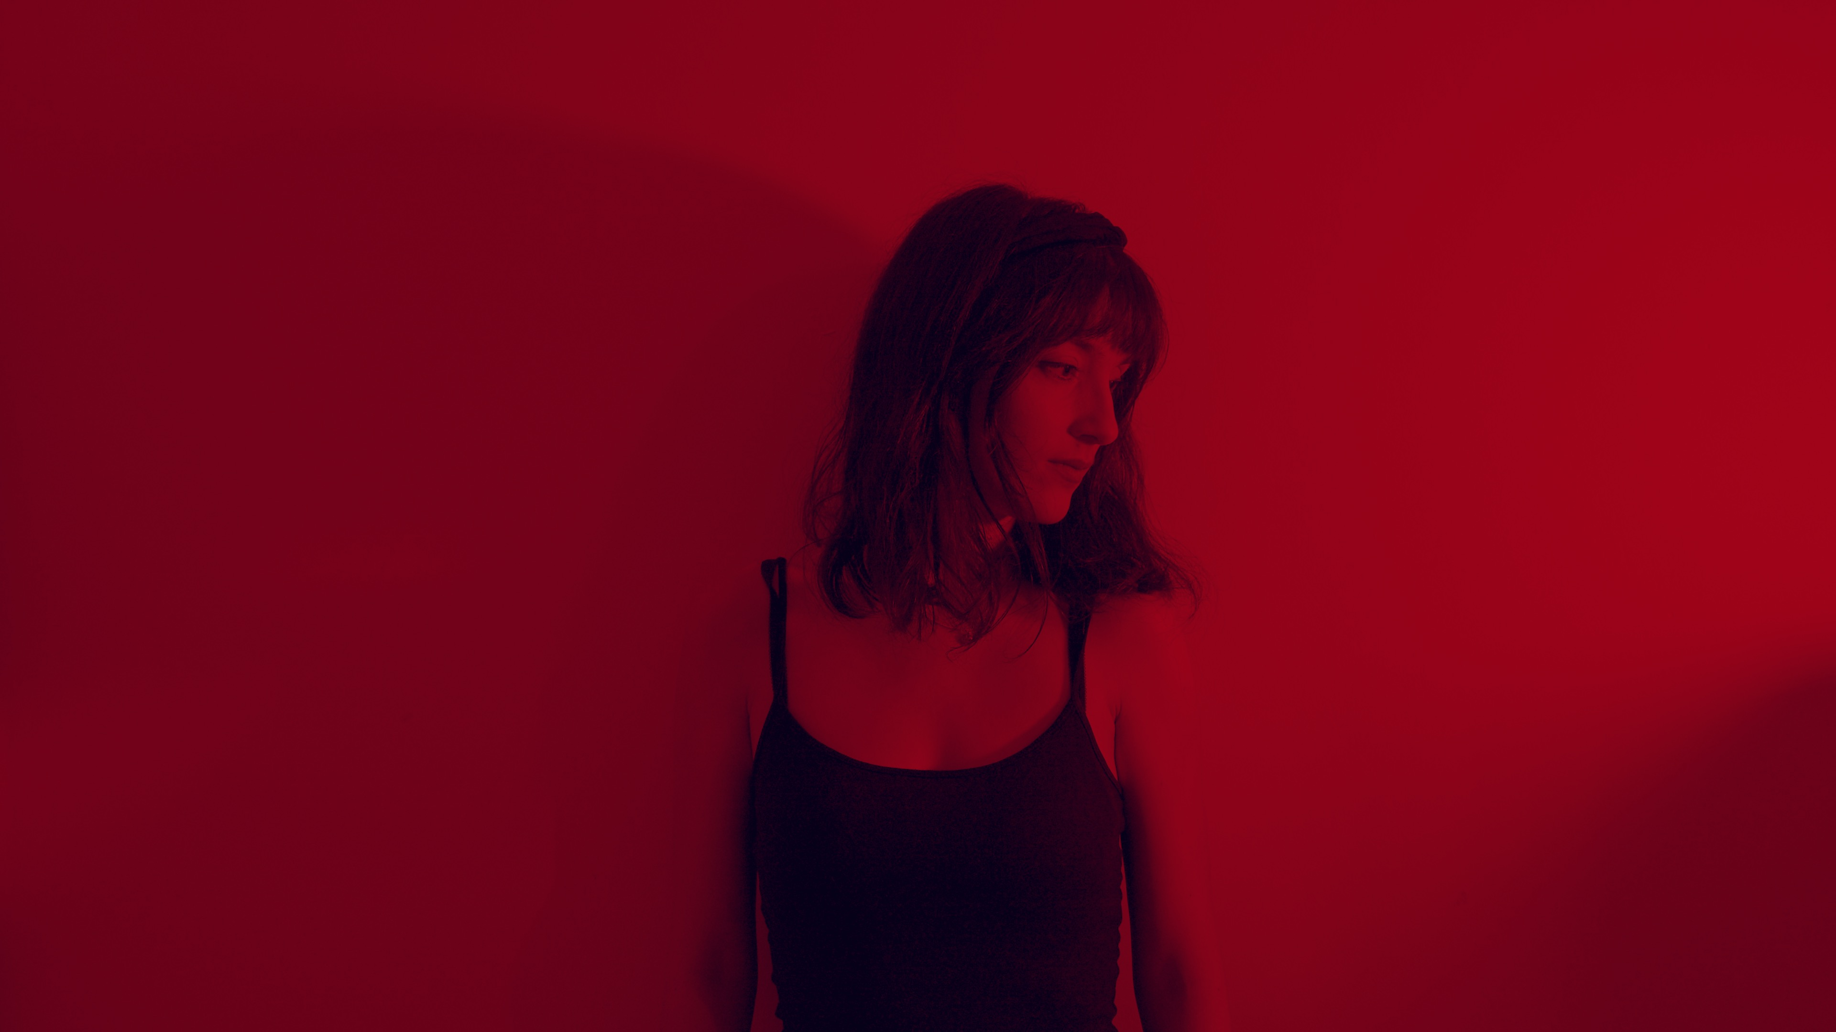

Is This World Mine
Out March 26

Listen here
Music Video
All platforms link

Is This World Mine
Jewelia shares moving snapshot of our times in new single ‘Is This World Mine’
Art pop reminiscent of MARINA and Kate Bush, with dreamy vocals, ambient/lo-fi elements, Billie Eilish bass and anthemic chorus, ‘Is This World Mine’ is about feeling powerless in a changing world.

The song
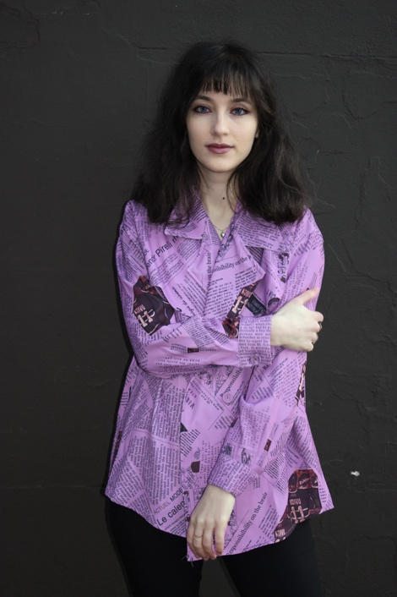
In 2020, a time where many artists struggled for inspiration, Jewelia found a way to force creativity by challenging herself to write, record and share with her fans a song every month. Born from this challenge, ‘Is This World Mine’ was written as a reflection upon what was a turbulent year.
“‘Is This World Mine’ is a song about feeling dislocated from reality. The pandemic has changed the world forever, and even when we go back to normal, the residue of these changes will stay with us. And all the other issues of modern society, which were momentarily overshadowed, will still be there.”
In a world where roughly 2% of music producers are women, Jewelia proudly self-produces her own songs. Furthermore, ‘Is This World Mine’ was mastered by Cicely Balston of AIR Studios, one of two women engineers nominated for the MPG Mastering Engineer of the Year award in 2021.
‘Is This World Mine' has already received airplay from BBC Upload in Kent. Previously, Jewelia received support from BBC Nottingham, BBC Introducing Three Counties, Eagle Radio and Cambridge 105, among others. Her debut album, which raised over $5000 on Kickstarter, was in top three albums of the year on Cam FM Breakthrough in 2019. Jewelia also received airplay on National FM and Europa FM in Romania after her song ‘Aquarium’ was chosen as the soundtrack of the award-winning mini-series, ’13 Shades of Romanian’, which also aired on Romanian television.

“Absolutely Excellent, a snapshot of the times we live in”
- Leo Ulph, BBC Radio Kent on ‘Is This World Mine’

“A piece of artistic brilliance (…) Jewelia’s voice will be echoing through the pages of history when people look back at this time”
- Chris West, Radio Phoenix on ‘Is This World Mine’

The Music Video
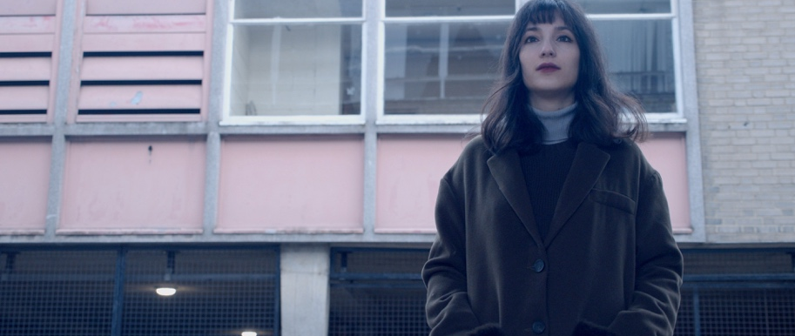
The video, filmed in lockdown, includes stock footage of world events, environmental catastrophe, protest movements and empty streets in the midst of a pandemic, interspersed with shots of Jewelia singing against a dark background and in an industrial-looking environment.
"What originally sparked me to write ‘Is This World Mine’ was a news story in October 2020 that another boat carrying refugees capsized in the English Channel. Two children, aged five and eight, as well as two adults died. What shocked me most was the volume of heartless comments I was seeing online, it left me with a feeling of dread.
‘Is This World Mine’ is about feeling powerless in a changing world, be that coronavirus, racism or climate change. I wanted to make sure this came through in the music video.”
The hopeless feeling of the song is countered by a hopeful glimpse in the last chorus, where images of wildlife, hope and love of all kinds are cut in, the message being that even in difficult times, we must remember that the world is full of beauty and wonder.

The Artist
Jewelia is London-based but originally hails from Bucharest, Romania. Her music is a mixture of piano-powered fairy tales and nostalgia infused indie pop, always focusing on emotion. Her eclectic style takes influences from the music of piano-driven songstresses like Kate Bush and Tori Amos and more modern pop artists such as Lana del Rey, MARINA or Billie Eilish.
Jewelia has been growing a strong online presence and has over one million total YouTube views on her channel.

social links

